URL: https://adityabirlahospital.com/blogs/dry-skin-in-winter-causes-risk-factors-and-prevention

Meta Title: Dry Skin in Winter: Causes, Symptoms & Prevention Tips

Meta Description: Understand dry skin in winter, common symptoms, risk factors, and effective prevention tips. Learn when to consult a skin specialist for treatment.

H1: Dry Skin in Winter: Causes, Risk Factors and Prevention
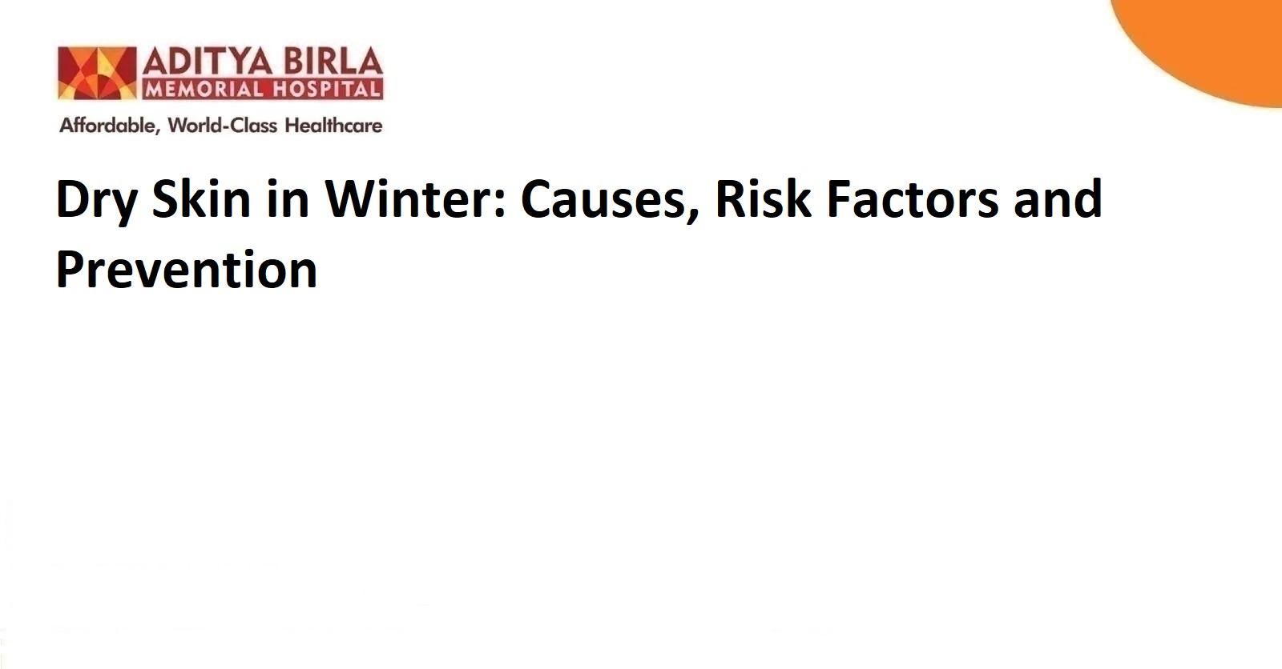
With the onset of winter, people around the world start to notice a tight or rough feeling on their skin. In most cases, the visibility of cracks, flaking or red patches is inevitable. This condition, often referred to as dry skin in winter, affects people of all age groups and skin types. Although winter is considered enjoyable for its cool weather, it may create severe discomfort for those with sensitive skin. Fortunately, recognising the triggers early helps prevent long-term damage and allows better care.

The Primary Cause of Dry Skin in Winter
There are several reasons why skin becomes dry during winter. But the most common factor is the sharp drop in humidity levels. Cold air holds very little moisture. This means that whenever you step outdoors, your skin begins to lose water at a faster rate than usual. At the same time, most indoor environments are heated. These heating systems may provide warmth, but they also pull moisture out of the air. As a result, the skin starts to feel dry, flaky and tight.

Excessive Showers
The skin has a protective layer made of natural oils. This layer helps seal in moisture and prevents irritation. When you take long, hot showers or use strong soaps during winter, this natural barrier breaks down. Once it is damaged, the skin loses its ability to retain moisture. The condition may become more severe with exposure to wind or pollution.

Regular Habits and Lifestyle Choices
Your lifestyle choices also play a role in the development of dry skin. For example, not drinking enough water or skipping moisturising routines may worsen the symptoms of dry skin. In some cases, sudden dry skin on the symptoms of dry skinhands may appear without warning. This usually happens when exposed to harsh cleaning agents or constant hand washing in low humidity.

Exposure to Excessive Stress
Another important trigger is stress! Scientific studies have shown how stress can damage your skin by affecting the skin’s ability to heal and retain hydration. It may weaken the protective barrier and lead to inflammation or flare-ups.

The Risk Factors Involved in Developing Dry Skin in Winter
Some individuals tend to develop symptoms earlier and more severely. Being aware of these risk factors helps reduce future discomfort and allows timely action to protect the skin.

Age and Skin Type
With age, the skin naturally becomes thinner and produces less oil. This reduction increases the chances of itchy, dry skin patches during colder seasons.

Medical Conditions
Individuals with eczema or psoriasis already have a compromised skin barrier, as these conditions often flare up in winter. People with diabetes or thyroid concerns may also experience reduced skin hydration due to changes in circulation or metabolism.

Lifestyle and Environment
Living in regions with harsh winters or high altitudes may expose the skin to extreme dryness. People who consume alcohol frequently or smoke may find it difficult to retain skin moisture because of reduced hydration and weaker surface protection.

Water and Product Exposure
Daily contact with hot water, chlorinated pools or strong cleansing products may damage the outer layer of the skin. This often leads to sudden dry skin on hands or flaking on visible areas. Fragrance-heavy or alcohol-based products increase the risk of developing a dry skin rash on the face.

Nutritional Deficiencies
Poor diets [lacking essential fats or vitamins] may weaken the skin barrier. In such cases, the body struggles to produce enough oils to keep the skin moisturised.

Preventing Dry Skin in Winter
The best approach to winter skincare is prevention. Once the skin becomes cracked or inflamed, it takes longer to repair. Following a few simple practices may help prevent dry skin in winter and reduce irritation.

Use Mild Cleansers and Lukewarm Water
Avoid hot showers or harsh soaps. Instead, use a gentle cleanser and lukewarm water to cleanse without stripping natural oils.

Moisturise Immediately After Bathing
Apply moisturiser when your skin is still slightly damp. This helps trap moisture and prevents dry skin rashes or flaking.

Layer Your Skincare Products
Begin with a light hydrating serum and follow up with a heavier cream or oil. This method strengthens the skin barrier and provides longer protection.

Install a Humidifier at Home
Use a humidifier in your bedroom or living area to add moisture back into the air. This is especially useful when indoor heating is in use.

Protect Skin from Wind and Cold
Wear gloves, scarves and protective clothing. This reduces moisture loss and shields the skin from harsh external conditions.

Stay Hydrated and Eat a Balanced Diet
Drink plenty of water even if you are not thirsty. Include foods rich in omega-3 fatty acids, vitamin E and antioxidants to support skin health from within.

Avoid Fragrance-Based Products
Products with artificial fragrances or alcohol often trigger irritation. Choose unscented, non-foaming formulations for cleansing and moisturising.

Gentle Exfoliation
Use a mild exfoliator once or twice a week. This helps remove dead skin cells and improves the absorption of hydrating products.

Watch for Early Signs
If you notice signs like dry skin itch relief not working or cracks developing, take a break from active ingredients and focus on soothing care.

Seek Specialist Care When Needed
For severe dry skin treatment or when over-the-counter options do not help, a consultation with a skin specialist in Pimpri-Chinchwad may offer more personalised guidance.

Conclusion
Dry skin in winter is a common but manageable condition! The key to prevention lies in daily habits, environmental care and consistent moisturisation. If the problem becomes difficult to manage, visiting the best dermatology hospital in Pimpri Chinchwad may help uncover deeper causes and start suitable treatment for dry skin on the face or body. Staying alert and informed is the best way to keep your skin soft, healthy and resilient all season.

FAQs

What deficiency causes dry skin in winter?
Deficiencies in vitamin D, vitamin E and essential fatty acids may reduce the skin’s ability to stay hydrated. A balanced diet [that includes good fats and antioxidants] supports skin moisture and improves texture.

What is the best way to prevent skin dryness?
Use a gentle cleanser, avoid hot water and apply moisturiser immediately after bathing. Keeping your living space humid and protecting your skin from the wind also helps prevent dry skin in winter.

Which vitamin is good for dry skin in winter?
Vitamin E supports skin barrier repair and improves hydration. Vitamin D plays a role in skin immunity and healing.

Which foods prevent dry skin?
Foods rich in healthy fats [such as nuts, seeds, avocados and oily fish] nourish skin from within. Bright-coloured fruits and vegetables that contain antioxidants also support the skin’s defence against dryness and damage.

References:

https://www.maxhealthcare.in/blogs/coping-dry-skin

https://www.amritahospitals.org/faridabad/blog/dry-skin-in-winter-causes-risk-factors-and-prevention



